**Chapter 01: General Notes, Cautions, and Assignment Deliverables**

**GBI Configuration Advanced**

|  |
| --- |
|  |

|  |
| --- |
| **ACKNOWLEDGEMENT**  These are advanced versions of the GBI configuration exercises initially developed by Simha R. Magal, Stefan Weidner, and Tom Wilder.  These exercises include complex configuration concepts discussed in the book, *Business Process Configuration with SAP ERP* (Epistemy Press, 2020). |

|  |
| --- |
| **MOTIVATION**  In this exercise, you will do the following:   1. Learn about the different texts, formats, and how to efficiently navigate the exercises 2. Learn how to navigate SAP and some useful tools to help you during the exercises 3. Learn how to turn in your assignment. |
|  |
|  |

|  |
| --- |
| **PRODUCT**  SAP S/4HANA 1709 |
|  |
| **REVISED**  2020-04-22 |
|  |
| **FOCUS**  General Notes, Cautions, and Exercise Deliverables |
|  |
| **AUTHORS**  Simha R. Magal  Ray Boykin  Bipin Prabhakar  Mary Beth Goodrich |
|  |
| **VERSION**  1.3  **TESTED**  Date: 2020-04-22  System Version: MGL |

|  |
| --- |
| **PREREQUISITES**   1. You should be familiar with navigation in SAP S/4HANA 2. You should be familiar with executing financial accounting   process in SAP S/4HANA |





© 2020 Epistemy Press, LLC.

Screenshots © 2020, SAP SE

* 1. Table of Contents

Contents

Section 1.1: Table of Contents 2

Section 1.2: Important Assignment Instruction’s 3

Section 1.3: How to Log On 5

Section 1.4: Where Do I Start? 6

Section 1.5: Navigation Path 7

Section 1.6: What is in a transaction? 11

Section 1.7: Finding Transaction Codes 13

Section 1.8: Viewing Help Guides 19

Section 1.9: The Search Tool 20

Section 1.10: SAP Search Menu 23

Section 1.11: Display/Change 24

Section 1.12: System Message Types 25

Section 1.13: Repeating Fields 28

Section 1.14: Pop-Ups 30

Section 1.15: Miscellaneous Reminders 31

Section 1.16: Logging Off 32

Section 1.17: Exercise Deliverable Instructions 33

Exercise Deliverables 35

* 1. Important Assignment Instruction’s

Before You Start

It is *strongly* recommended that you read through the entire exercise you are working on prior to starting work in the system. READ CAREFULLY! Each step and additional information/instructions were put there *for a reason*! This can help avoid a lot of confusion and hours of extra work for yourself. Read through the exercise to try and understand what you are trying to accomplish from the business perspective, look at the big picture.

Important Symbols

* An arrow highlights an important instruction that must not be overlooked.

🖉 A pencil prompts you to write down an important piece of information.

Identifiers

You will be assigned, by your professor, a unique Identifier. This will be ASSIGNED FOR YOUR OWN USE ONLY!!! Your Identifier is used to differentiate your company, your products, and *your work* from other students.

The ## Symbol

## is the placeholder for your Identifier in the assignments. When you see ## replace ## with Your Identifier. For example, if Alec has an identifier of 09 and Alec sees US##, Alec will enter US09 into the system.

1. What is your Identifier?  
          🖉
2. If you saw GL## what would you input into the system?  
          🖉
3. What does a red arrow mean?  
          🖉
4. What does a Pencil mean?  
          🖉

* Always work with your data. You have access to other student’s companies and if you do not use your own company code you affect another student’s work.

Important Assignment Formats

Please be cautious about other classmates attempting to use your identifier. Whether it is on purpose or not. If you suspect other classmates using it, inform your professor immediately so that corrective action can be made.

Tables

In each exercise, you will have input fields that need to be filled in. This is information the system needs to perform what you are requesting it to do. These will be given to you in the form of tables with three columns. The first column is called the Attribute column; this column is the name of the field. The second column is the Description column; this tells you about the Attribute. The final column is the Data Value column; this column tells you what to enter into the input field in SAP.

|  |  |  |
| --- | --- | --- |
| **Attribute** | **Description** | **Data Value** |
|  |  |  |

Differences in Font

Text with different fonts will be used in the Data Value column of tables. The different fonts will require you to do different things. The normal Calibri indicates you enter exactly what is typed out except for the ## Symbol where you would put in your identifier. The italicized *Calibri* font indicates the data is looked up, found, or otherwise not to be entered literally as written.

You will learn to search for info later in this exercise

|  |  |  |
| --- | --- | --- |
| **Attribute** | **Description** | **Data Value** |
| Calibri | Font that tells you to enter what is written. | Calibri |
| Calibri | Font that tells you the data that needs to be looked up. | Calibri |

**Using the table below answer the following questions**

|  |  |  |
| --- | --- | --- |
| **Attribute** | **Description** | **Data Value** |
| Company Code | An organizational unit within financial accounting. | US## |
| Company Name | Name of Company Code or Company | ## Global Bike Inc. |
| City | City name in an address. | Dallas |
| Country | The country key contains information which the system uses to check entries such as length of the postal code or bank account number. | US |

1. For each row in the table write the value that you will type into the system input field. If you must search for the value answer the question with “Search for Value”
   1. Row 1:       🖉
   2. Row 2:       🖉
   3. Row 3:       🖉
   4. Row 4:       🖉
      1. Answer the following questions about Section I.1
2. What should you do when you see a Red Arrow in your assignments?  
          🖉
3. What should you do when you see a pencil?  
          🖉
   1. How to Log On

* Your instructor will provide instructions for logging into the SAP S/4 HANA system
  1. Where Do I Start?

There are two areas of SAP that you will use in your assignments. These are called the **SAP Easy Access menu** that you’ve already seen and the **SAP Customizing Implementation Guide**.

1. Using the “SAP Easy Access” menu

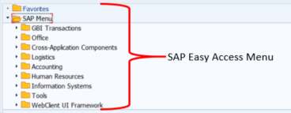This is the side of SAP that business professionals use to complete the normal business functions needed to complete their job. The SAP Easy Access menu appears when you start a session. These are the folders that contain the transactions you will enter when you test your system to make sure your configuration was set up correctly.

1. Using the “SAP Customizing Implementation Guide” menu.

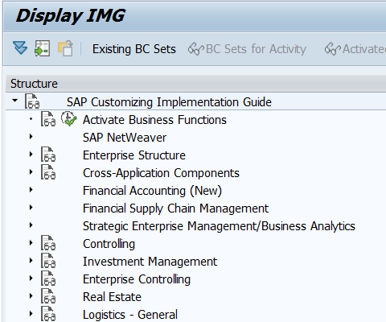The SAP Customizing Implementation Guide is the part of the system that is used to configure and maintain the SAP system. This is used by SAP consultants who set up a company’s system. You will use this part of the system the most since this course is about the configuration of the SAP system.

In the next section, you will learn about how to navigate the SAP Easy Access Menu and transaction menus and then you will learn about The SAP Customizing Implementation Guide.

1. Who uses the SAP Easy Access Menu?  
          🖉
2. Who uses the SAP Customizing Implementation Guide?  
          🖉
   1. Navigation Path

Using the SAP Easy Access Menu:

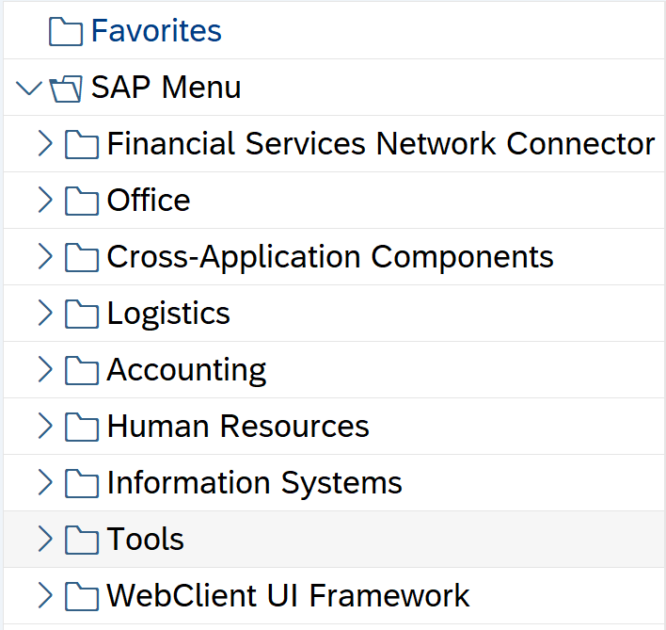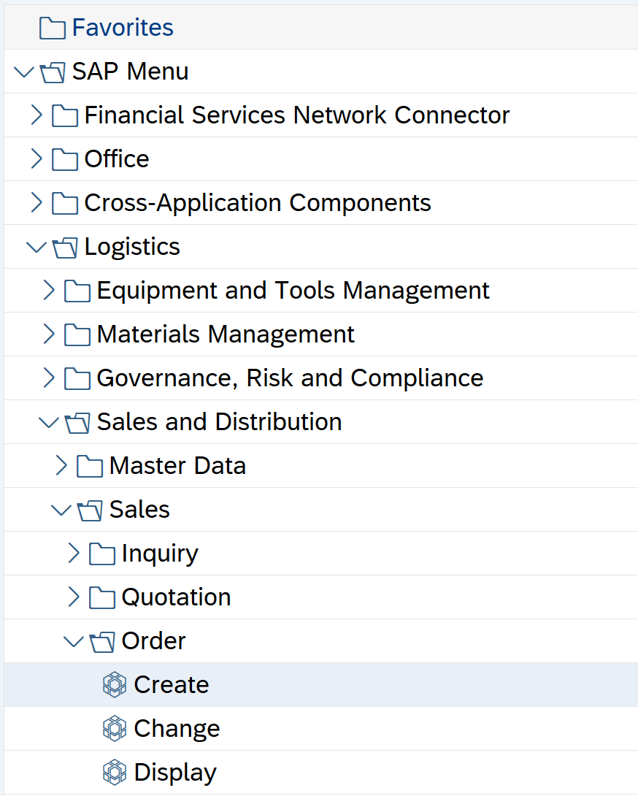Opening the folders to get to a transaction is called the **Navigation Path**. A navigation path always ends with a transaction.

1. What does a navigation Path always end with?  
          🖉

When you are going through your assignments you will be given navigation paths to follow. They will be in the following format.

Navigation

SAP Menu🡪 Logistics 🡪 Sales and Distribution 🡪 Sales 🡪 Order 🡪 Create

* + 1. Follow the Navigation path starting from the SAP Easy Access Screen.
* Do not enter the transaction.
* 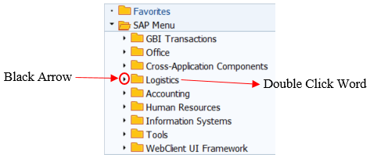To open the folders either double click on the folder, or click the black dropdown arrow next to the folder.

Now that you have all the folders open you will want to close them.

1. Why might you want to close the SAP Menu Path?  
          🖉
   * 1. In the Application Menu Bar click on the SAP Menu button 
2. What does the SAP Menu button do?  
          🖉
   * 1. Now create your own Navigation Path by filling out the blank navigation path below:
3. Create Your Own Menu Path:

Navigation

      🡪       🡪       🡪       🡪       🡪       🡪       🡪       🡪       🡪       🡪       🡪       🡪       🡪       🡪

You do not need to fill in all the fields, just be sure you start at the SAP Menu folder and end at a transaction.

* You do not need to enter the transaction.

Using the SAP Customizing Implementation Guide:

This is the part of SAP you will use the most in your exercises. This is the section of SAP where configuration of the system is carried out. There are two ways to get there:

The first is to proceed through the SAP Easy Access menu path to get there. Follow the Navigation path below and enter the transaction:

Navigation

SAP Menu🡪 Tools 🡪 Customizing 🡪 IMG 🡪 Execute Project

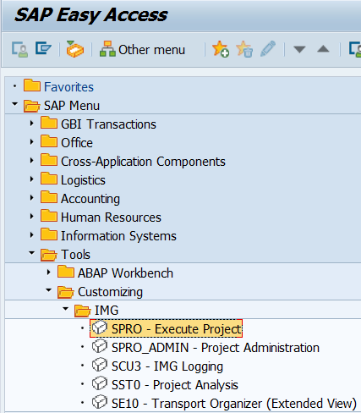

* You enter a transaction the same way you open a folder.

1. How do you enter a transaction?  
          🖉
   * 1. In the *“Customizing: Execute Project”* screen, click Display SAP Reference IMG .

You have now entered the SAP Customizing Implementation Guide

* + 1. Click on the Exit Button  twice.

To exit using another method, type “/n” into the command field 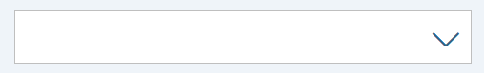and press ENTER. This will bring you back to the main screen.

1. What does the “/n” command do?  
          🖉
   * 1. 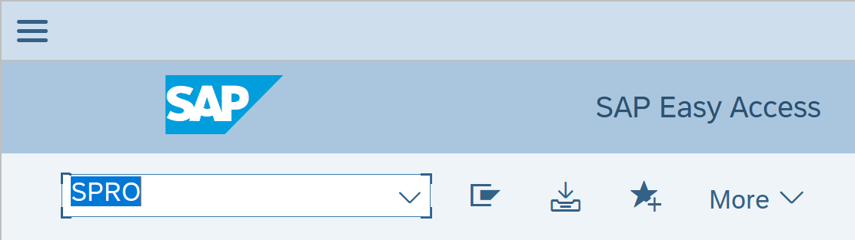The Second way to get there is using a transaction code. In the *“SAP Easy Access”* screen, type *“SPRO”* in the command field and Press Enter.
2. What part of SAP is the command field a part of?  
          🖉
   * 1. In the *“Customizing: Execute Project”* screen, click SAP Reference IMG .

* At the end of each Section to go back to the SAP Easy Access Screen or the SAP Customizing Implementation Guide.

1. What is one way to get back to the SAP Easy Access Screen?  
          🖉
   1. What is in a transaction?

This section describes the different parts of a transaction menu. Some of the parts will be familiar to you from the SAP Easy Access Screen.

* + 1. Follow the Navigation Path below

Navigation

SAP Menu 🡪 Logistics 🡪 Sales and Distribution 🡪 Sales 🡪 Order 🡪 Create

* + 1. In the *“Create Sales Order: Initial Screen”*, enter the following information:

|  |  |  |
| --- | --- | --- |
| **Attribute** | **Description** | **Data Value** |
| Order Type | Distinguishes different types of sales documents | OR |

* + 1. Press Enter.

**Example of One Transaction Screen and Its Elements:** When you enter a transaction, there are different elements you will want to pay attention to. Take note of these elements because they will be referred to in later exercises.

Notice a few of these you saw earlier

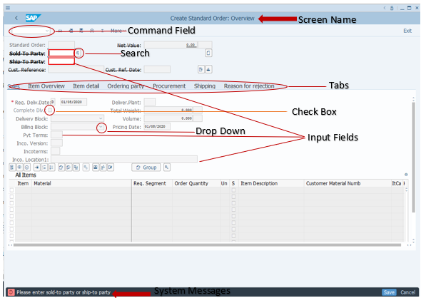

1. There are four new elements that you have not seen in the exercise yet, what are they?  
          🖉
   * 1. Exit this transaction and return to the SAP Easy Access Menu

Screen Layout:

* + 1. Follow the Navigation Path below:

Navigation

SAP Menu 🡪 Logistics 🡪 Materials Management 🡪 Purchasing 🡪 Purchase Order 🡪 Create 🡪 Vendor/Supplying Plant Known

* There will not always be all three sections, but it is important that you understand this general concept.

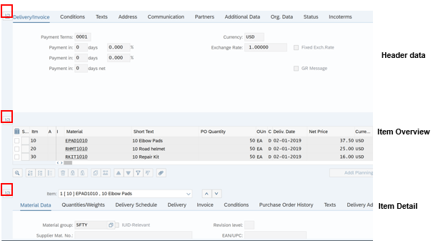

* You may edit data in any section depending on which sections you have opened or expanded

1. What are the names of the three collapsible sections in the create purchase order screen?  
          🖉
   1. Finding Transaction Codes

Each exercise will ask you what the Transaction Code or T-Code for that transaction is. T-codes are a short code you can type into the command field to go straight to the transaction.

T-Codes are extremely important for business professionals because it cuts down on time by eliminating the need to go through the menu path. While the menu path is important, it is not as important for your everyday business professional that may only use a few transactions.

There are two ways you will use to find T-Codes. It depends on if you are in the SAP Customizing Implementation Guide or the SAP Easy Access Menu.

If the Transaction is using the SAP Menu:

Once you set this up the first time you will not have to do it again. It is recommended that you follow these instructions and set this up now before you start the next exercises.

* + 1. 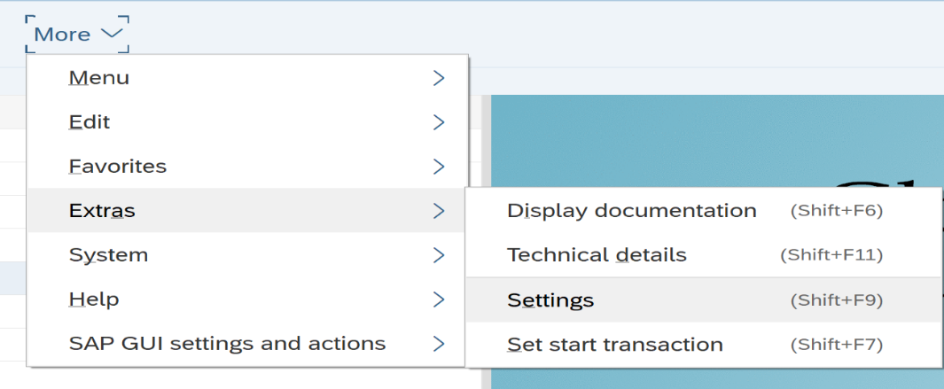On the SAP Menu Bar Click More 🡪 Extras 🡪 Settings
    2. 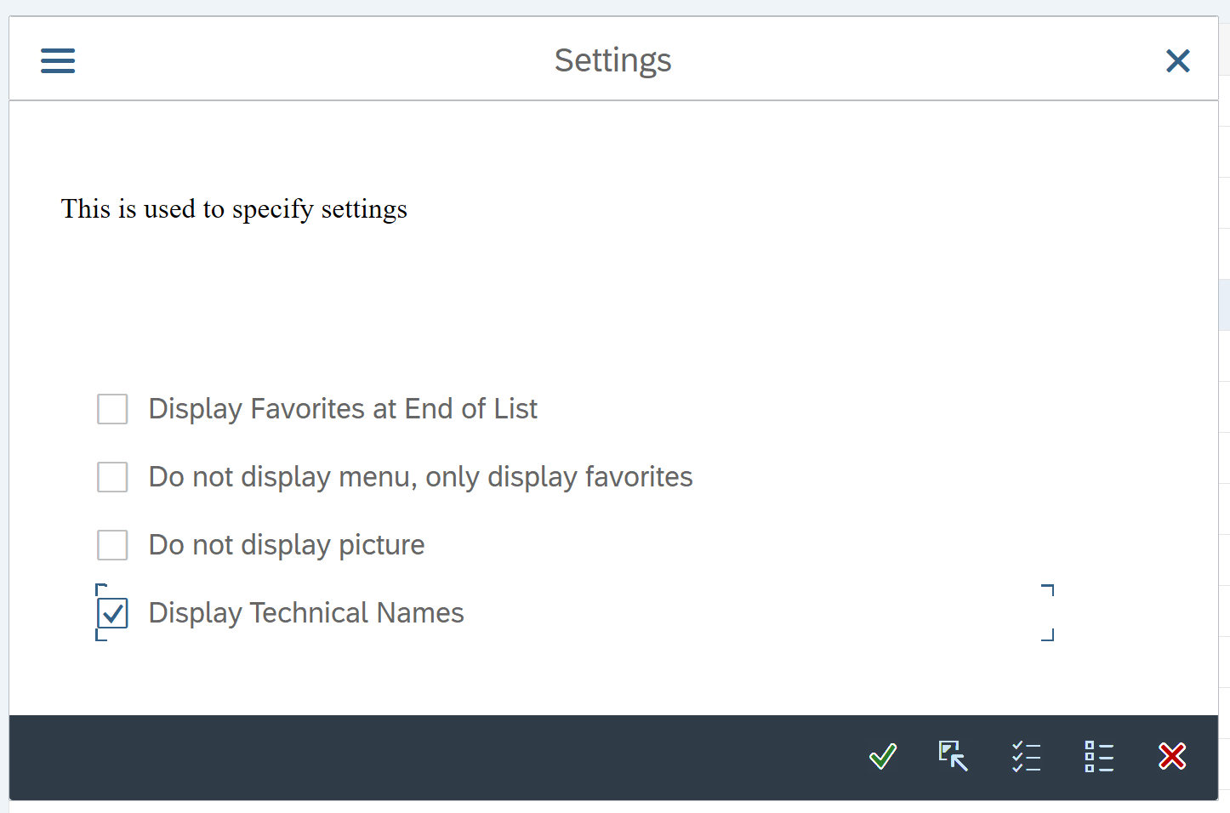In the *“Settings”* Pop-up, check the box next to *“Display Technical Names”.*
* This will display the transaction code on the same line as the name of the transaction
  + 1. In the Settings pop-up, click Enter .

Now when you open the folders and look at the transaction they will have the Transaction codes in front of the name of the transaction.

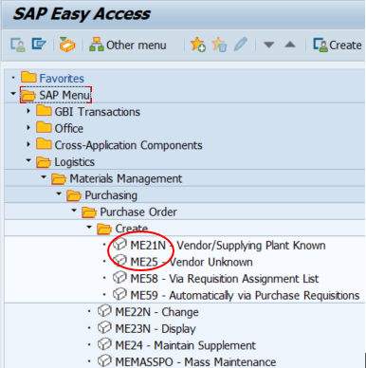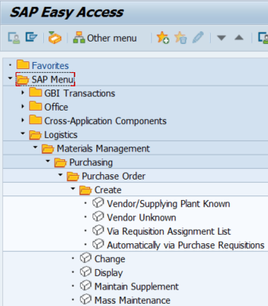Before After

If the Transaction is using the SAP Customizing Implementation Guide:

Option 1: Last four Characters

* + 1. Follow the menu path below in the SAP Menu Bar

Navigation

SAP Customizing Implementation Guide 🡪 More 🡪 Additional Information 🡪 Additional Information 🡪 Display Key 🡪 IMG Activity

Notice the Additional information column was added to the *“Display IMG”* screen.

* + 1. Follow the Menu Path Below:

Navigation

SAP Customizing Implementation Guide 🡪 Financial Accounting 🡪 General Ledger Accounting 🡪 Master Data 🡪 G/L Accounts

Notice that the last four characters of the line of information in the Additional Information column for the “Define Financial Statement Versions” transaction are “OB58”.

This is the T-Code for the transaction “Define Financial Statement Versions”.

* + 1. Click Execute  next to “Define Financial Statement Versions” to enter the transaction.
    2. Click New GUI button 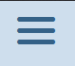 and select New GUI.
    3. In your New Session, type “OB58” in the Command Field.
* If you receive a warning popup about the data being locked, simply click “Yes” to dismiss the message. This only means that you have the data open in another screen.
* Are the screens the same? Yes. – This means you have found the transaction code for “Define Financial Statement Versions”.

1. What is the transaction code to Define Financial Statement Versions?  
          🖉

Option 2: Display Technical Details

* + 1. Follow the Menu Path Below

Navigation

SAP Customizing Implementation Guide 🡪 Financial Accounting 🡪 General Ledger Accounting 🡪 Master Data

* + 1. Click the Execute Button  for the *“Define Statistical Key Figures”* Transaction.
* Notice how there are two options you can choose, “Create Statistical Key Figures” and “Change Statistical Key Figures”.
  + 1. Close  the *“Select Activity:”* pop-up.
    2. *Right* click on the Execute Button next to the *“Define Statistical Key Figures”* Transaction.
    3. Click “Display Technical Info”.

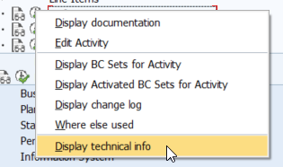

* + 1. Click on the *“Maint. Objects”* Tab.
    2. In the Assigned Objects section of the screen, the Transaction Column tells you the transaction codes for *“Create Statistical Key Figures”*, KK01, and *“Create Statistical Key Figures”*, KK02.
    3. Repeat Steps 1.8.9 to 1.8.11. Use NA00 as the Controlling Area.

1. What is the Transaction code for “Create Statistical Key Figures”?  
          🖉
2. What is the Transaction code for “Change Statistical Key Figures”?  
          🖉

Option 3: SM30 – Last and least desirable option

* Only use this option if the other two options do not work.
  + 1. Follow the Menu Path Below:

***Navigation***

SAP Customizing Implementation Guide 🡪 Financial Accounting 🡪 General Ledger Accounting 🡪 Master Data 🡪 G/L Accounts

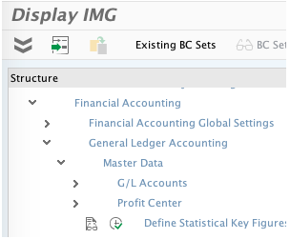

1. What is one way you can get to the SAP Customizing Implementation Guide?  
          🖉
   * 1. Right click on the Execute Button  for *“Define Financial Statement Versions”*.
     2. Click *“Display Technical Info”*.
     3. Click on the *“Maint. Objects”* Tab.

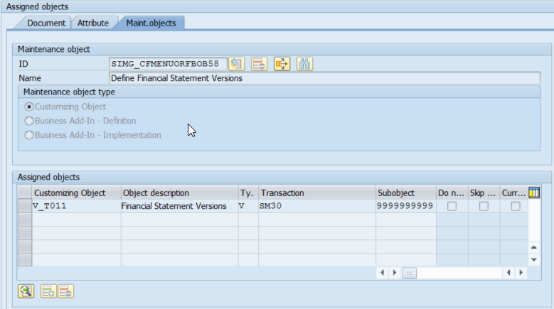

* The transaction code, “SM30”, is the transaction code for Table Maintenance. Which means you need to include the Customizing Object. The Customizing Object is the first column, and it is what you need to put in the Table Maintenance Screen to take you to the actual Transaction, “V_T011”.

1. What is the transaction code for “Define Financial Statement Versions”?  
          🖉
2. What is the customizing object?  
          🖉
   * 1. Click Back .

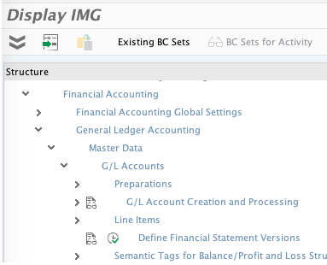

* + 1. Enter the *“Define Financial Statements Versions”* transaction by clicking the execute button .
    2. In the *“Change View “Financial Statement Versions”: Overview”* screen, Click Creates New Session .
    3. In your new window, type the transaction code into the command field.
    4. Press Enter.
    5. In this *“Maintain Table Views: Initial Screen”*, enter the following information:

|  |  |  |  |
| --- | --- | --- | --- |
| **Attribute** |  | **Description** | **Data Value** |
| Table/View |  | Customizing object input field | V_T011 |

* + 1. Click Display .

1. What is the title of the screen you entered?  
          🖉

* This should be the same screen you entered in earlier except it will say Display instead of Change.
  1. Viewing Help Guides

At times, certain attributes or fields may not appear to have the name of them displayed on the screen. To display the full name of the attribute or field, simply click within the field and then press the F1 key, or the Help button . This will bring up not only the title of the field, but it will bring up the full description.

In this section, you learn how to use the “Performance Assistant” tool to help you find answers to error messages or to find the definition or explanation of a field within the SAP system.

* + 1. In the *“SAP Easy Access”* screen, follow the navigation path below:

***Navigation***

**SAP Menu 🡪 Accounting 🡪 Financial Accounting 🡪 Accounts Receivable 🡪 Account 🡪 Display Balances**

1. What is the Transaction Code to Display Balances?  
          🖉
   * 1. In the *“Customer Balance Display”* screen, click on the *“Customer”* field.

* Do not enter any customer information in the field.
  + 1. Press on the “F1” key on your keyboard.

1. What is the “Customer Account Number” definition?  
          🖉
   * 1. In the *“Performance Assistant”* pop-up, click close .
     2. In the *“Customer Balance Display”* screen, click help .

* Notice that performing either one of these actions displays the “Assistant” tool.
  + 1. Close the *“Performance Assistant”* pop-up and return to the main menu.
  1. The Search Tool

At times in this document, the instructions will ask you to search for something to put in a field. When it does, simply click on the input field and click on the search icon to the right of it , or click on the F4 button while inside the input field. Clicking on it will bring up another window and you will search from there.

In this section, you will practice using the search box that appears next to a field when entering data into it. You will also learn how to navigate and use the proceeding menus and pop-ups.

Navigation

SAP Menu 🡪 Accounting 🡪 Financial Accounting 🡪 Accounts Receivable 🡪 Account 🡪 Display Balances

* + 1. In the *“Customer Balance Display”* screen, click inside the *“Customer”* field.
    2. Notice the box with a magnifying glass in it that appears next to the field. 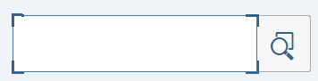
    3. Click Search.
    4. In the *“Customer Account Number”* pop-up, enter the following information:

|  |  |  |
| --- | --- | --- |
| **Attribute** | **Description** | **Data Value** |
| Maximum No. of Hits | Restrict Length of List | 5000 |

* + 1. Leave all the other fields blank and click start search 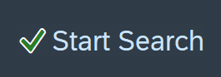.

This will show you a list of nearly all (5000, which is the maximum SAP will allow for search results) of the customers that are defined in the system.

* Ensure that the “Customers (general)” tab is selected at the top.

Notice that the many different tabs are different ways of giving search criteria. You can scroll through them using the arrow buttons at the top right.

1. Why might someone use this method of searching with no specific criteria?  
          🖉
   * 1. Click the drop-down bar near the top of the screen to show the search menu.

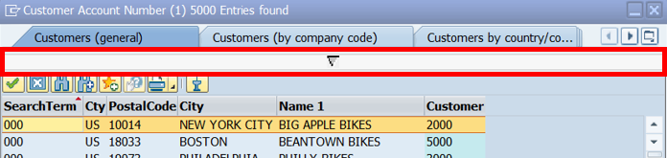

* + 1. Enter the following information:

|  |  |  |
| --- | --- | --- |
| **Attribute** | **Description** | **Data Value** |
| Search Term | Predefined in the system. | 0## |
| Maximum No. of Hits | Restrict Length of List | 500 |

* + 1. Leave all the other fields blank and click start search 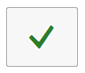.

This will show you a list of every customer associated with your identifier. This is a specific design of GBI. Every one of your customers, when they were created in the system, was assigned a three-digit search term that corresponds to your identifier, thus you entered 0## in the “search term” field. This will also work with vendors in future assignments.

* + 1. Click the search bar near the top of the screen to show the search menu.
    2. Click the button at the very top right corner of that looks like this: 
* This menu allows you to use other methods of searching for what you want.
  + 1. Choose the *“Customers (by company code).”* tab.
* You can accomplish the same result by navigating to whichever tab you want by using the arrow buttons .
  + 1. In the *“Customer Account Number”* pop-up, enter the following information:

|  |  |  |
| --- | --- | --- |
| **Attribute** | **Description** | **Data Value** |
| Company Code | An organizational unit within financial accounting | US00 |

* + 1. Press Enter.
* This will show you a list of all (limited to 500) of the customers associated with the US00 company code.
  + 1. Click the search bar near the top of the screen to display the search menu.
    2. Clear the information in the *“Company Code”* field.
    3. In the *“Customer Account Number”* screen, enter the following information:

|  |  |  |
| --- | --- | --- |
| **Attribute** | **Description** | **Data Value** |
| Customer | Gives an alphanumeric key, which clearly identifies the customer or vendor in the SAP system. | *000 |

* + 1. Click start search .

The asterisk symbol represents a wild card, meaning anything can be before 000. This will show you a list of every customer that has a customer number ending in your identifier.

1. Why would someone use the “*” in a search?  
          🖉

Now that you know the various methods of searching, try using other criteria and exploring different searching methods to familiarize yourself with the system.

* 1. SAP Search Menu

Before this step, you accessed the “Customer Balance Display” screen by navigating through the menu path and using a transaction code. In this step, you will learn how to use the SAP search menu. The search menu enables you to find a specific page by searching key words.

* + 1. In the *“SAP Easy Access”* screen*,* type “search_sap_menu” in the command field.
    2. Press Enter.
    3. In the *“Enter transaction code or menu text”* pop-up, enter the following information:

|  |  |  |
| --- | --- | --- |
| **Attribute** | **Description** | **Data Value** |
| Enter Search Text | Field that you enter a transaction code or menu text title | Display Balances |

* + 1. Click Enter .

This will bring up another screen that will list all the locations “Display Balances” appears in the SAP menu. Use the scroll bar on the right side of the screen to see all the available options. Notice that you can access the same screen by using different transaction codes. The reason for this is that multiple job positions may have to access this information (accountants, sales representative, credit managers, etc.). The sixth listing is the transaction code that you have used in this exercise thus far within the system.

1. What is the sixth transaction code?  
          🖉
2. How many different menu paths can you use to display balances?  
          🖉
   * 1. Return to the main menu and repeat steps I.II.1 – I.II.4 and in I.II.4, enter the following information:

|  |  |  |
| --- | --- | --- |
| **Attribute** | **Description** | **Data Value** |
| Enter Search Text | Field that you enter a transaction code or menu text title | Material Master |

1. What is the first transaction code?  
          🖉
2. What is the reason that there are so many menu paths that you can use to access the same transaction?  
          🖉
   1. Display/Change

Some steps will ask you to use the Change/Display button . It is important to use this button because when you change the screen from Change to Display it doesn’t allow any changes to be made in the screen. If you are in a cross-company screen that affects everyone it is good to view this screen in the display mode. This way you do not accidentally change something that affects everyone’s work.

* + 1. Follow the Navigation Path below:

Navigation

SAP Customizing Implementation Guide 🡪 Financial Accounting 🡪 Financial Accounting Global Settings 🡪 Ledgers 🡪 Fiscal Year and Posting Periods 🡪 Maintain Fiscal Year Variant

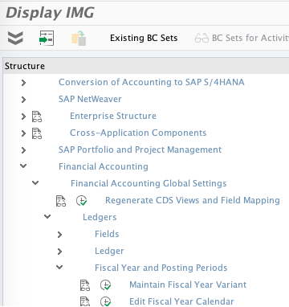

1. What is the Transaction code to Maintain the Fiscal Year Variant?  
          🖉
   * 1. In the *“Change View “Fiscal year variants”: Overview”* screen, Click Change -> Display .
2. What happened after you hit the display/change button?  
          🖉
3. Why is it important to use this button?  
          🖉
   1. System Message Types

There are three types of messages you will receive when completing your assignments

If you double-click on the message it will give you detailed information about the message.

1. (Red) Error Messages: Red Error Messages indicate that something is stopping the transaction from being completed. These messages need to be corrected to proceed through the exercises.



1. (Yellow) Warning Messages: Yellow Warning Messages contain warnings and are there to tell you about some sort of information that may be helpful later, or warn you about the possible effects of what you are about to do. At times, these must be fixed to move on. However, most of the time, they do not need to be fixed and you can simply press enter to cancel them and go through them. Use your best judgement to determine what needs to be done.



1. (Green) Confirmation Messages: Green messages show that nothing went wrong with the transaction and that you may proceed to the next task. These messages will contain information you will want to write down and take note of.



This section will help to familiarize you further with the different system messages by having you produce each type and figure out how to get past it.

* + 1. Follow the Navigation Path Below:

Navigation

SAP Menu 🡪 Logistics 🡪 Materials Management 🡪 Purchasing 🡪 Purchase Order 🡪 Create 🡪 Vendor/Supplying Plant Known

1. What is the transaction to create a Purchase Order?  
          🖉
   * 1. In the *“Create Purchase Order”* screen, enter the following information:

* Go ahead and close the user interface pane in the left side of the screen if it opens.

Remember what was said in a previous step about the different sections of the screen. You may have to open additional sections and explore the tabs to find this field.

|  |  |  |
| --- | --- | --- |
| **Attribute** | **Description** | **Data Value** |
| Purch. Org | Org unit in Logistics, subdividing an enterprise per the requirements of Purchasing | US00 |

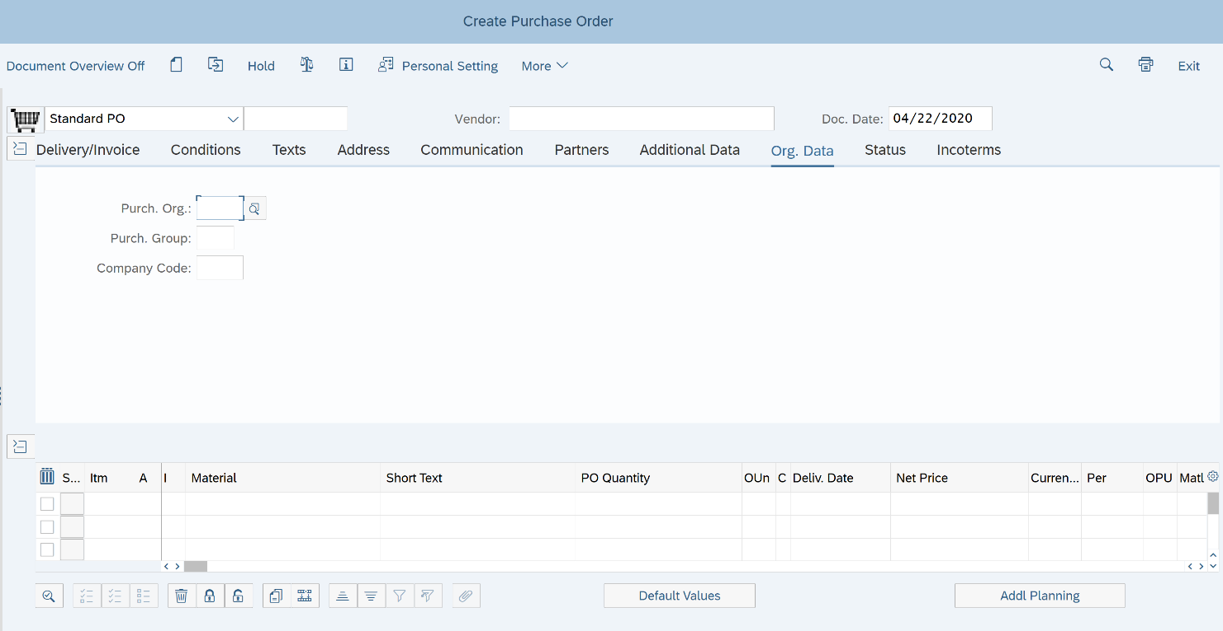

* + 1. Press Enter.

IMPORTANT NOTE: USING ENTER

Once you click the enter button or press “enter” on your keyboard, the system checks to ensure that you have entered all the data that is required in the document.

If you have not, it will ask you to enter valid data into each field, ONE BY ONE, through messages. After entering data into the designated field, you must PRESS ENTER AGAIN to move on to check the system for more messages.

Once you have filled in all the required information, the rest of the fields in the screen will unlock. Then you can edit the fields as you could before you initially clicked enter and received the messages.

In this case, the other fields may never have locked but it is important to understand this concept for later exercises.

You want to use this technique before you save EVERY DOCUMENT.

It is extremely important to NOT proceed and save a document if there are errors in the document. A faulty document will create more errors and a lot more work for yourself in later exercises.

* Notice that the system shows an error message which, in this case simply tells you exactly what you need to input into the system to continue.
* If you need more information or want more information about a message, you can double click on the message to open the help guide.
  + 1. Double click on the error message.

1. What is the message being displayed?  
          🖉
   * 1. To resolve the error message *“Enter Purch. Group”*, enter the following information:

|  |  |  |
| --- | --- | --- |
| **Attribute** | **Description** | **Data Value** |
| Purch. Group | Key for a buyer or a group, who is/are responsible for certain purchasing activities | N00 |

* + 1. Click Enter .
    2. When you receive the error message *“Enter a vendor”* enter the following information:

|  |  |  |
| --- | --- | --- |
| **Attribute** | **Description** | **Data Value** |
| Vendor | Number and name of the external supplier or supplying plant from which the materials are to be procured. | 101000 |

* + 1. Click Enter .
* Notice here how it does not produce another error message and you are now free to edit the rest of the fields as you wish. This means you have entered all the required data.
  + 1. In the *“Create Purchase Order”* screen, enter the following information:
    2. If the *“Item Overview”* section is not open, you must open it and enter this data there.

|  |  |  |
| --- | --- | --- |
| **Attribute** | **Description** | **Data Value** |
| Material | The goods that are the subject of business activity | EPAD1000 |
| PO Quantity | Quantity ordered by the buyer, to be supplied by the vendor | 1 |
| Delivery Date | Date on which the goods are to be delivered or the service is to be performed. | *Today’s Date* |
| Net Price | Price after taking all vendor surcharges and discounts into account per unit | 37.50 |
| Plnt | Plant in which you produce or for which you wish to produce materials or services | MI00 |

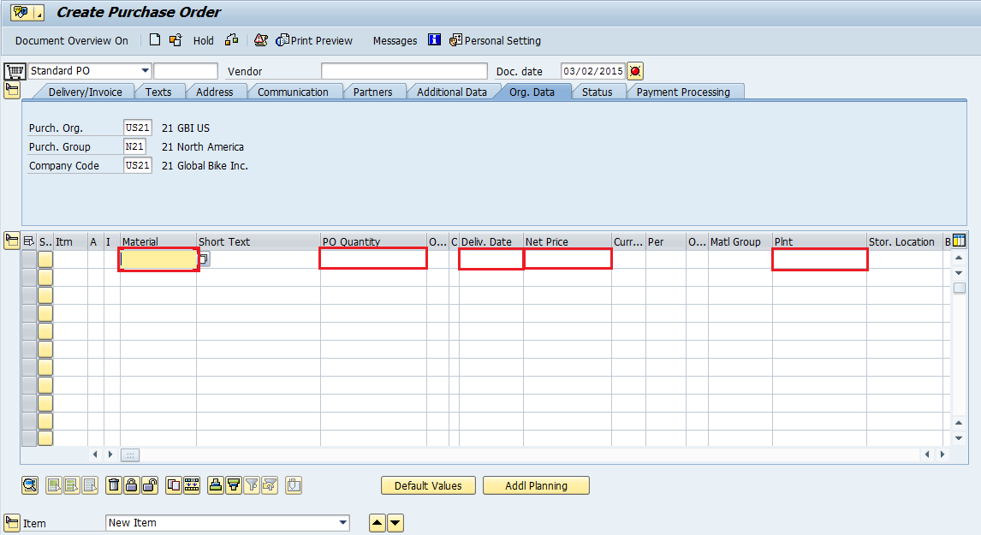

* + 1. Click Enter .
* You should notice a warning message saying, “Can delivery date be met?” The system realizes that the date you entered is today’s date, and it knows it normally takes more time than that to receive materials. This message serves the purpose of warning you about that fact, but since it is just a warning, you may ignore it and continue.
  + 1. To bypass the message, click Enter  to acknowledge the warning and move on.
    2. Click Exit .
* DO NOT save this document. The purpose of this exercise was to familiarize you with these two types of system messages.
  + 1. In the *“Exit Document*” pop-up, click No *.*

Remember, it is extremely important to NOT proceed and save a document if there are errors in the document. A faulty document will create more errors and a lot more work for yourself in later exercises.

* 1. Repeating Fields

When going through your assignments you must type in the same information many different times in the same field. A little annoying, but SAP has developed a way around this. Professionals use this feature all the time because they are in the same transactions daily and where your information may change for educational purposes their information will stay the same. Setting repeating fields to the same value provides an easy way to cut time on processing for business professionals.

* + 1. Follow the Navigation Path Below:

***Navigation***

**SAP Menu Bar 🡪 More 🡪 System 🡪 User Profile 🡪 User Data**

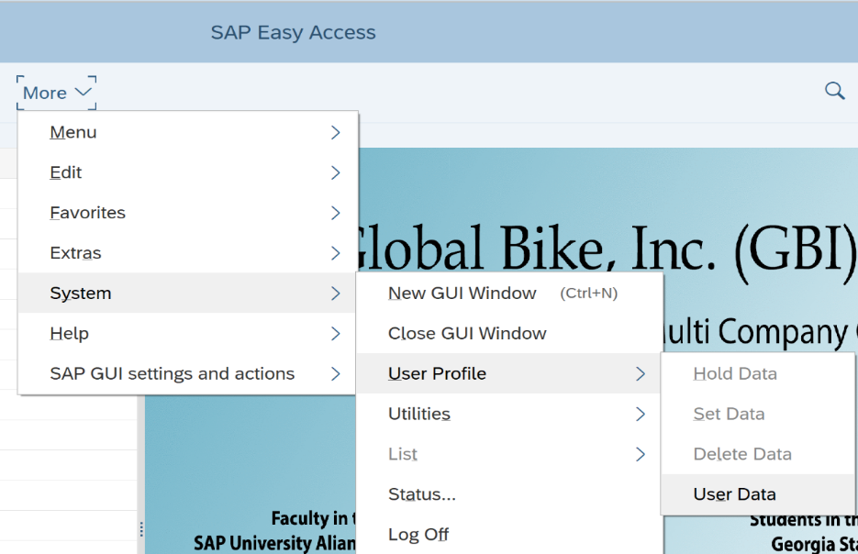

* + 1. In the *“Maintain User Profile”* screen, click on the “Parameters” Tab
    2. In the Parameters Tab click the search box in the first EMPTY *“Set/Get Parameter ID”* input box .

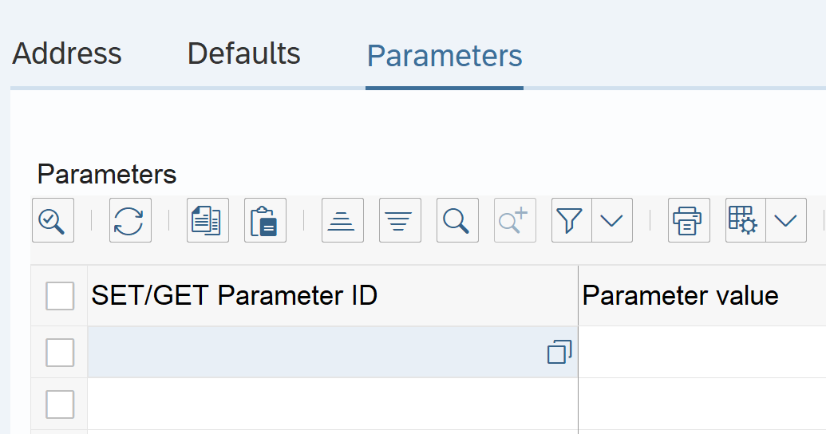

* + 1. In the *“Set/Get parameter ID (#) 500 Entries found”* screen, click the dropdown arrow at the top of the screen.



* + 1. Enter the Following information:

|  |  |  |
| --- | --- | --- |
| **Attribute** | **Description** | **Data Value** |
| SET/GET parameter ID | Short Description of Repository Objects | /BA1/F4**_**CCY |

* + 1. Click Enter 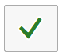
    2. Click the Check Box next to /BA1/F4_CCY 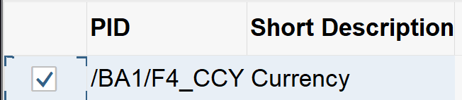
    3. Click Copy 
    4. Repeat steps I.14.3 to I.14.8 with the following information:

|  |  |  |
| --- | --- | --- |
| **Attribute** | **Description** | **Data Value** |
| SET/GET parameter ID | Short Description of Repository Objects | BUK |

* + 1. In the *“Maintain User Profile”* screen, enter the following information:

|  |  |  |
| --- | --- | --- |
| **Attribute** | **Description** | **Data Value** |
| Parameter Value for /BA1/F4_CCY | Specifies a default value for a field for the parameter. | USD |
| Parameter Value for BUK | Specifies a default value for a field for the parameter. | US## |

1. What do you think entering this information will do?  
          🖉
   * 1. Click Save .

**Saving:** When the instructions to tell you to save data, remember to always press the “Enter”  key first. This will validate your data, and check for any errors. If there are error(s) that occur, they MUST be corrected before continuing to the next task. *If you do not correct the mistake you will have bigger errors later in your project!*

Now every time the input fields “Currency” or “Company Code” pop up they will automatically be filled in with your user information. You can do this with any other field that comes up frequently in the exercises.

Keep in mind that this information is linked to your User Profile, not your GBI company.

* 1. Pop-Ups

This section explains two different pop-ups that occur when completing the exercises and what to do when you get these popups.

Controlling Area Pop-Up:

At times, there will be times when the system asks you to enter your controlling area to clarify which controlling area you are configuring for.

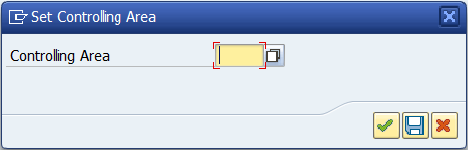

* + 1. If this should happen, in the *“Set Controlling Area”* pop-up, enter the following information:

|  |  |  |
| --- | --- | --- |
| **Attribute** | **Description** | **Data Value** |
| Controlling Area | Uniquely identifies a controlling area. | NA## |

* + 1. Click Enter .

This will get you into the next screen where the instructions will then tell you what to do for the task.

Enter Chart of Accounts Pop-Up:

At times, there will be times when the system asks you to enter your chart of accounts to clarify which chart of accounts you are configuring for.

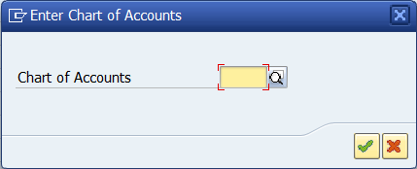

* + 1. If this should happen, in the *“Enter Chart of Accounts”* pop-up, enter the following information:

|  |  |  |
| --- | --- | --- |
| **Attribute** | **Description** | **Data Value** |
| Chart of Accounts | Key that uniquely identifies a chart of accounts. | GL## |

* + 1. Click Enter .
  1. Miscellaneous Reminders

Opening Multiple Screens

Throughout the exercises you will be asked to gather the same information after each step in multiple exercises. This is so you can see the changes that happen throughout the process. In these cases, it is helpful to open multiple screens. Use the New GUI Window Button  in the standard toolbar to open a new session.

Between Each Step

Each section will assume you are starting with one screen in the SAP Easy Access Menu. At the end of each section feel free to close out of your screens so you only have one screen open and is at the SAP Easy Access Menu.

In the Same Transaction

If you receive the message below about data being locked talk to your professor and they should be able to fix the issue. This should not happen unless instructed into the exercise.

In some exercises, you will receive this message but will be instructed to click through it to display the information. What the message is saying is that you have locked your user data for editing. No one else should be locking your information.

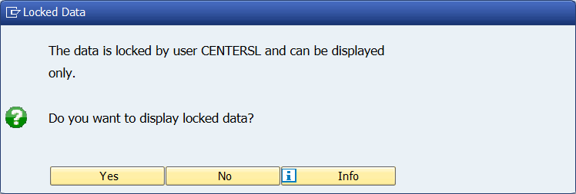

* 1. Logging Off

When you are finished with this assignment and you wish to log out, you may exit the SAP GUI by clicking the  button at the top right of the screen. You may also exit by repeatedly clicking Exit . When you receive a pop-up, click  to log off.

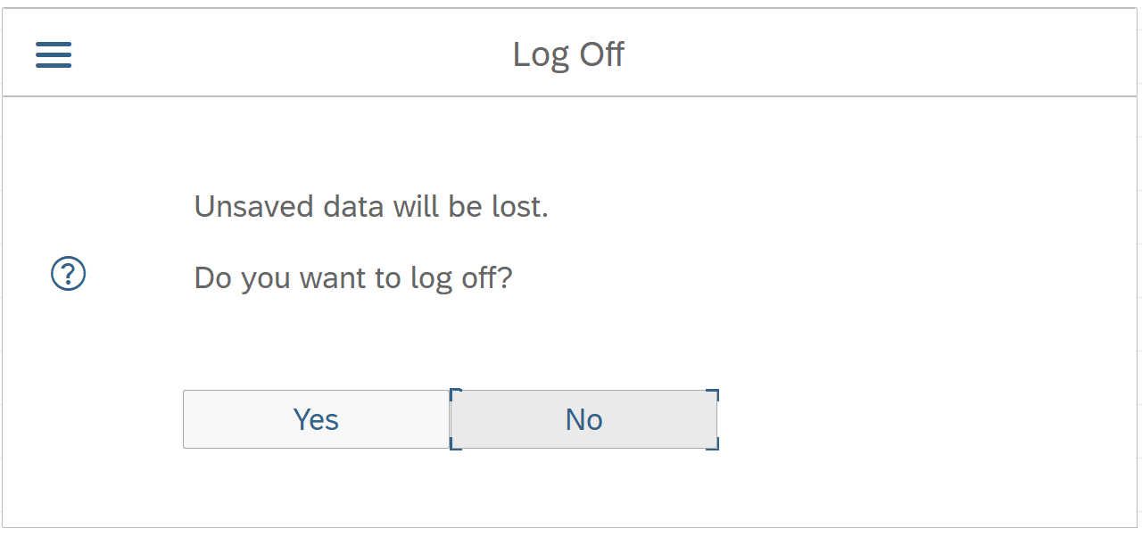

* 1. Exercise Deliverable Instructions

Exercise Deliverables

Deliverables are consolidated into one worksheet at the end of the exercise. It is only necessary to turn in that worksheet and that worksheet alone. You may be assigned additional deliverables, make sure to check with your instructor.

Question Text Fields

Each test field (see image) after the questions will automatically fill in the Exercise Deliverables. These fields are designed to “Calculate on Exit” which means that after you answer the question be sure you press “Tab” on your keyboard to exit the field so it can fill in your answer on the Exercise Deliverables page(s).

Export to a PDF

When you complete an assignment, it is important that you turn in just the deliverables page. You can do this by exporting your Exercise Deliverables to a PDF document.

* + 1. Use SAVE AS to save your document
    2. After you have found the location you wish to save the file to change the “Save as Type:” to PDF(*.pdf)

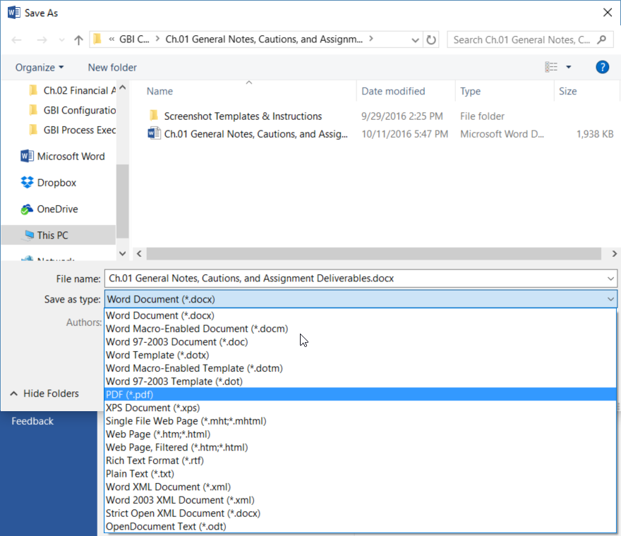

* + 1. Click on the Option Button

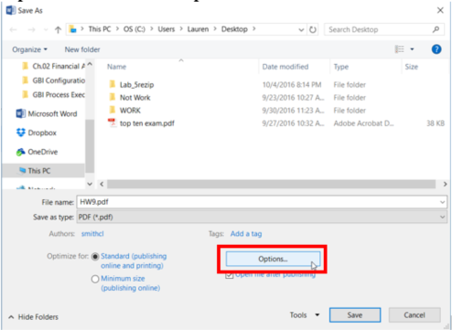

* + 1. Click on the “Pages” button and change the pages to the Exercise Deliverables page numbers.
* For example: On pages 39 & 40 of this exercise is the Exercise Deliverables. When you click on the Pages button you will change it to say “From: 39 To: 40”

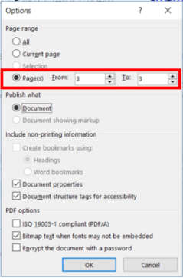

* + 1. Click “OK” and then “Save” your document.

Exercise Deliverables

**Name:**

**Course and Section:**

**Identifier:**

**Client:**

1. What is your Identifier?  
    🖉
2. If you saw GL## what would you input into the system?  
    🖉
3. What does a red arrow mean?  
    🖉
4. What does a Pencil mean?  
    🖉
5. For each row in the table write the value that you will type into the system input field.
   1. Row 1: 🖉
   2. Row 2: 🖉
   3. Row 3: 🖉
   4. Row 4: 🖉
6. What should you do when you see a Red Arrow in your assignments?  
    🖉
7. What should you do when you see a pencil?  
    🖉
8. Who uses the SAP Easy Access Menu?  
    🖉
9. Who uses the SAP Customizing Implementation Guide?  
    🖉
10. What does a navigation Path always end with?  
     🖉
11. Why might you want to close the SAP Menu Path?  
     🖉
12. What does the SAP Menu button do?  
     🖉
13. Create Your Own Menu Path

***Navigation***

**🡪** **🡪** **🡪** **🡪** **🡪** **🡪** **🡪** **🡪** **🡪** **🡪** **🡪** **🡪** **🡪** **🡪**

1. How do you enter a transaction?  
    🖉
2. What does the “/n” command do?  
    🖉
3. What part of SAP is the command field a part of?  
    🖉
4. What is one way to get back to the SAP Easy Access Screen?  
    🖉
5. There are four new elements that you have not seen in the exercise yet, what are they?  
    🖉
6. What are the names of the three collapsible sections in the create purchase order screen?  
    🖉
7. What is the transaction code to Define Financial Statement Versions?  
    🖉
8. What is the Transaction code for “Create Statistical Key Figures”?  
    🖉
9. What is the Transaction code for “Change Statistical Key Figures”?  
    🖉
10. What is one way you can get to the SAP Customizing Implementation Guide?  
     🖉
11. What is the transaction code for “Define Financial Statement Versions”?  
     🖉
12. What is the customizing object?  
     🖉
13. What is the title of the screen you entered?  
     🖉
14. What is the Transaction Code to Display Balances?  
     🖉
15. What is the “Customer Account Number” definition?  
     🖉
16. Why might someone use this method of searching with no specific criteria?  
     🖉
17. Why would someone use the “*” in a search?  
     🖉
18. What is this seventh transaction code?  
     🖉
19. How many different menu paths can you use to display balances?  
     🖉
20. What is the first transaction code?  
     🖉
21. What is the reason that there are so many menu paths that you can use to access the same transaction?  
     🖉
22. What is the Transaction code to Maintain the Fiscal Year Variant?  
     🖉
23. What happened after you hit the display/change button?  
     🖉
24. Why is it important to use this button?  
     🖉
25. What is the transaction to Create a Purchase Order?  
     🖉
26. What is the message being displayed?  
     🖉
27. What do you think entering this information will do?  
     🖉